Topalian
JavaScript
Piano
by
Christopher Andrew Topalian

All Rights Reserved
Copyright 2000-2024
Dedicated
to
God the Father

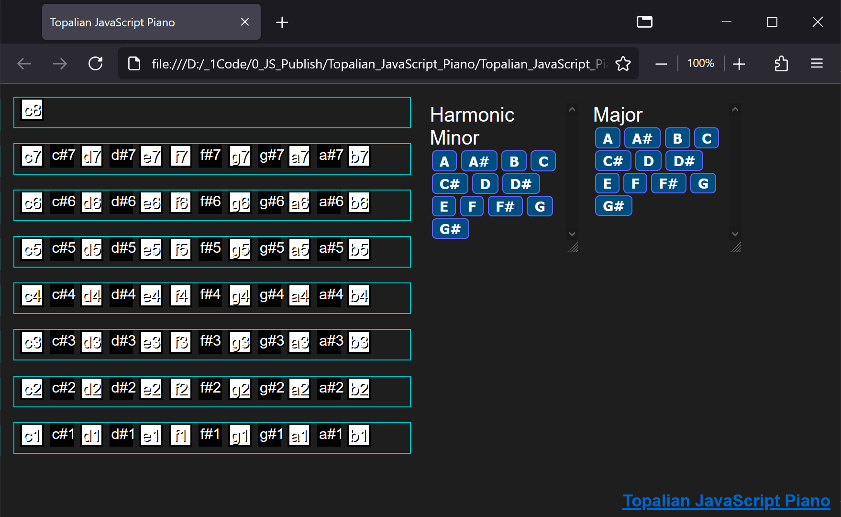
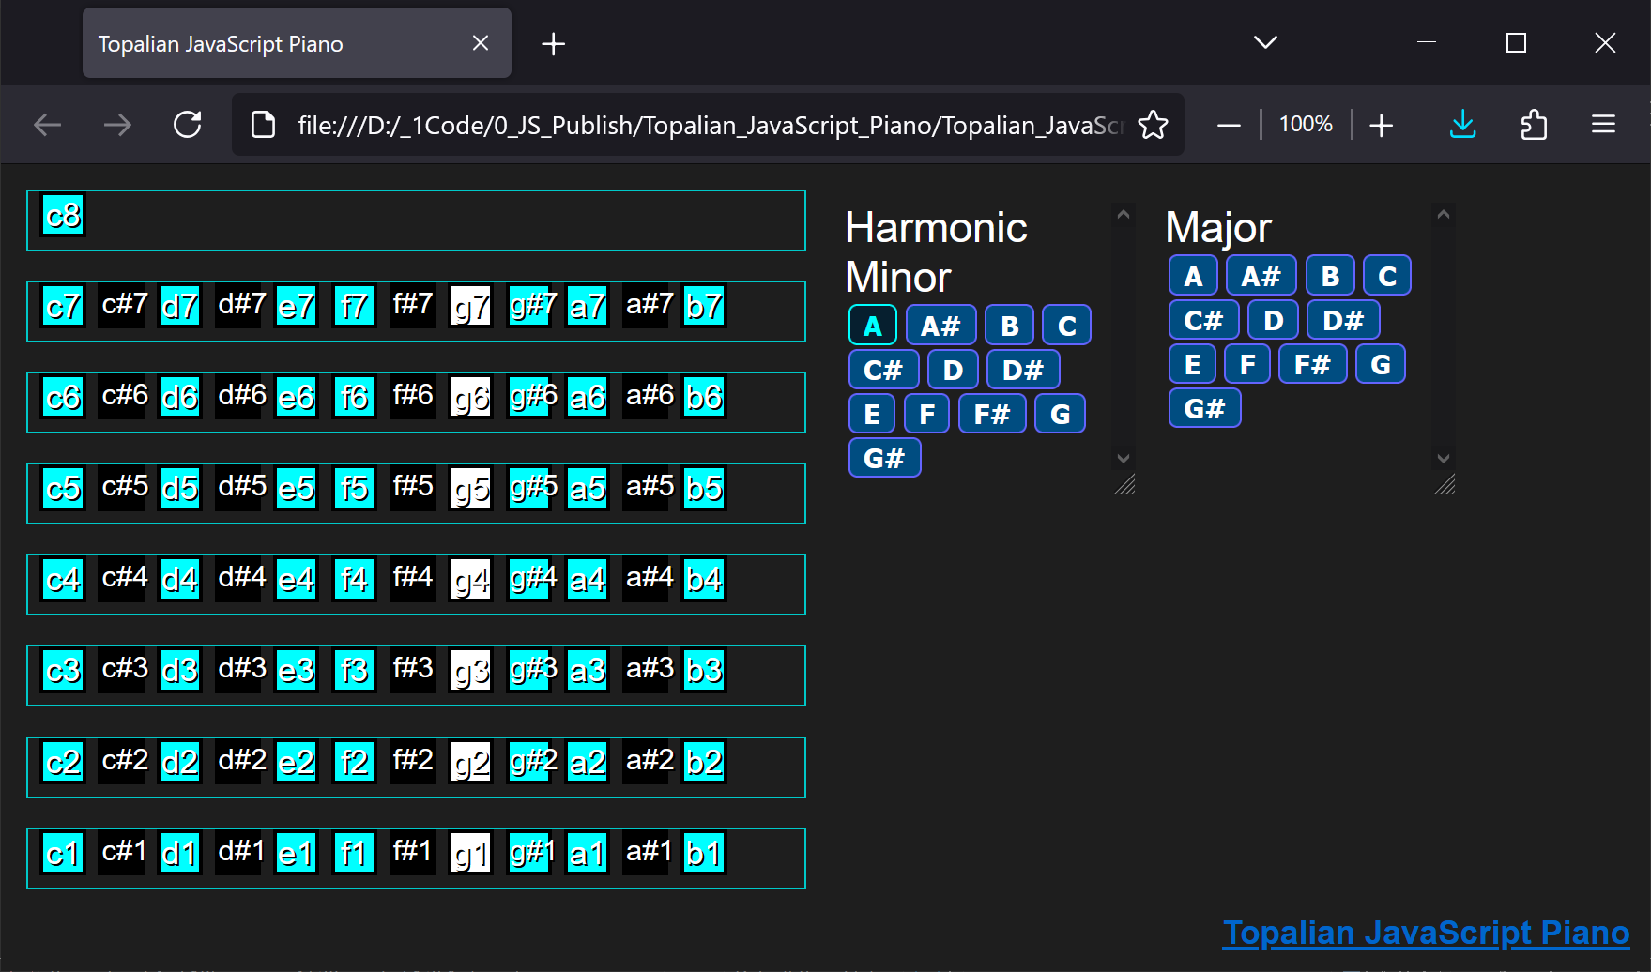

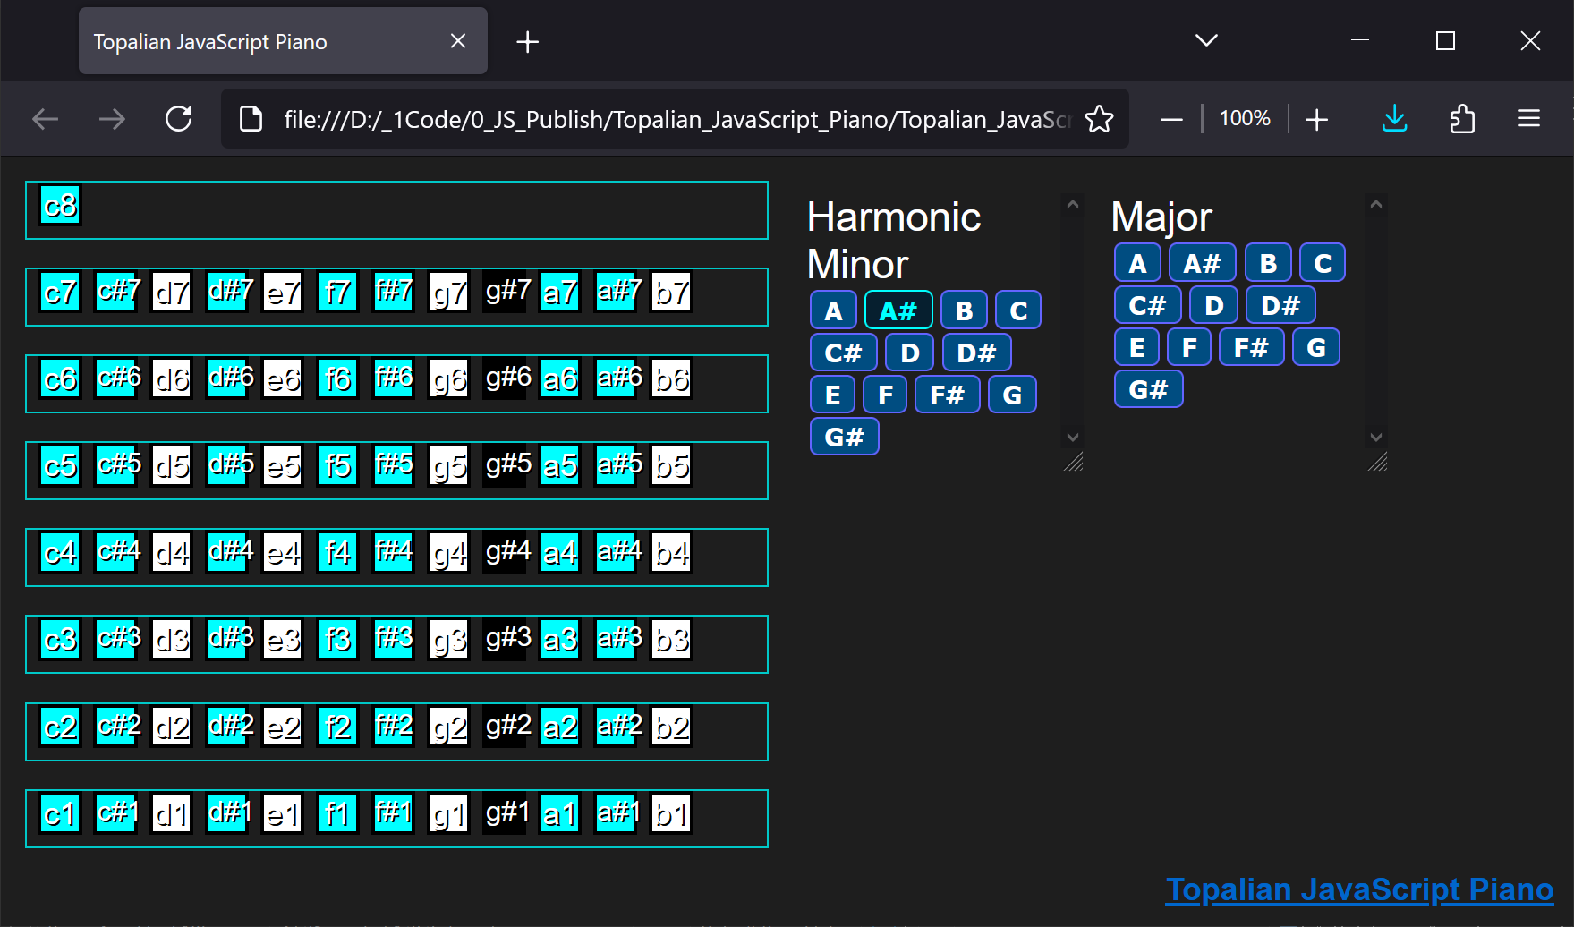
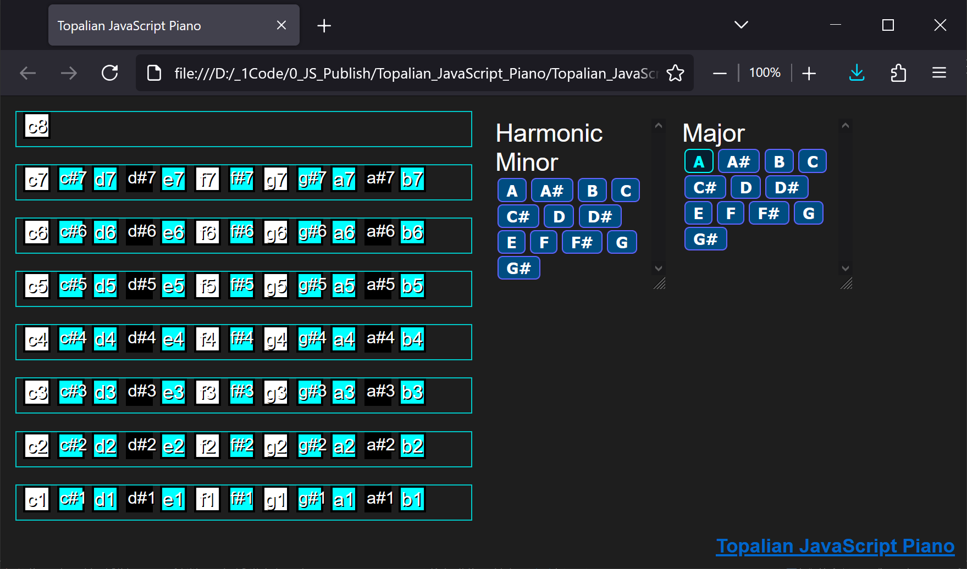

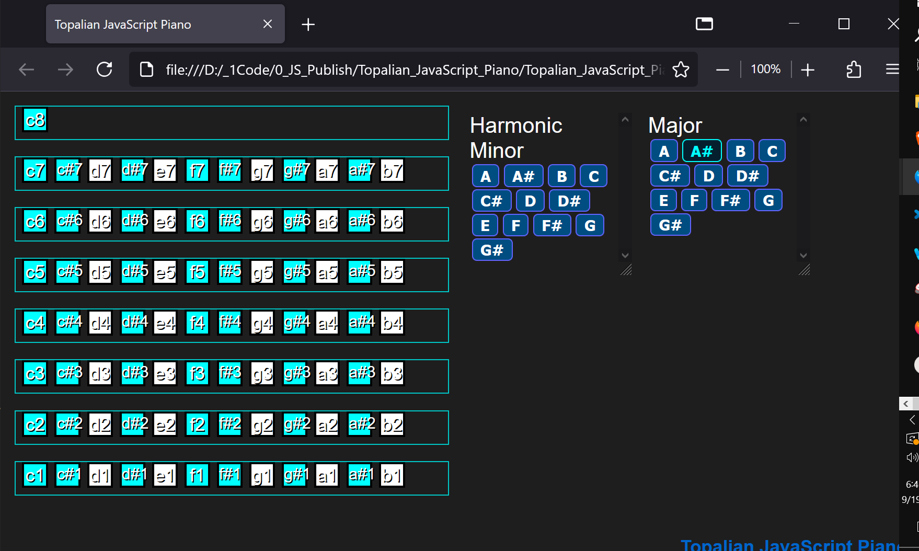
<!-- Dedicated to God the Father -->
<!-- All Rights Reserved Christopher Andrew Topalian Copyright 2000-2024 -->
<!-- https://github.com/ChristopherTopalian -->
<!-- https://github.com/ChristopherAndrewTopalian -->
<!-- Topalian_JavaScript_Piano(Online_Version).html -->
<!-- Version 001 - (2024-09-19) -->

<html>
<head>
<title> Topalian JavaScript Piano </title>

<style>

/* style001.css */

body
{
background-color: rgb(30, 30, 30);
}

.natural
{
width: 25px;
background-color: rgb(255, 255, 255);
border: solid 1px rgb(0, 0, 0);
font-family: arial;
font-size: 17px;
color: rgb(255, 255, 255);
text-align: center;
text-shadow: 1px 1px black;
user-select: none;
}

.natural:active
{
transform: translateY(3px);
background-color: rgb(200, 200, 200);
border-color: rgb(0, 255, 255);
box-shadow: inset 0 4px 5px rgba(0, 0, 0, 0.5);
color: rgb(255, 0, 255);
}

.sharp
{
width: 25px;
background-color: rgb(0, 0, 0);
border: solid 1px rgb(0, 0, 0);
text-align: center;
font-family: Arial;
font-size: 15px;
color: rgb(255, 255, 255);
text-shadow: 1px 1px black;
user-select: none;
}

.sharp:active
{
transform: translateY(3px);
background-color: rgb(200, 200, 200);
border-color: rgb(0, 255, 255);
color: rgb(255, 0, 255);
box-shadow: inset 0 4px 5px rgba(0, 0, 0, 0.5);
}

button
{
background-color: rgb(0, 77, 129);
margin-left: 2px;
margin-right: 2px;
margin-top: 1px;
margin-bottom: 1px;
border-style: solid;
border-width: 1px;
border-color: rgb(100, 100, 255);
border-radius: 4px;
padding-left: 7px;
padding-right: 7px;
padding-top: 1px;
padding-bottom: 1px;
opacity: 1.0;
font-size: 14px;
font-weight: bold;
color: rgb(255, 255, 255);
text-align: center;
}

button:hover
{
background-color: rgb(6, 31, 47);
border-color: rgb(0, 255, 255);
color: rgb(0, 255, 255);
}

button:active
{
color: rgb(255, 0, 255);
}

/* -- */

/* Dedicated to God the Father */
/* All Rights Reserved Christopher Andrew Topalian Copyright 2000-2024 */
/* https://github.com/ChristopherTopalian */
/* https://github.com/ChristopherAndrewTopalian */

</style>

<script>

// shortcuts.js

function ge(whichId)
{
let result = document.getElementById(whichId);
return result;
}

function ce(whichType)
{
let result = document.createElement(whichType);
return result;
}

function ba(whichElement)
{
let result = document.body.append(whichElement);
return result;
}

function ct(whichText)
{
let result = document.createTextNode(whichText);
return result;
}

//--//

// Dedicated to God the Father
// All Rights Reserved Christopher Andrew Topalian Copyright 2000-2024
// https://github.com/ChristopherTopalian
// https://github.com/ChristopherAndrewTopalian

// worldVariables.js

let online = true;

let natural = 'rgb(255, 255, 255)';
let sharp = 'rgb(0, 0, 0)';
let highlight = 'rgb(0, 255, 255)';

//--//

// Dedicated to God the Father
// All Rights Reserved Christopher Andrew Topalian Copyright 2000-2024
// https://github.com/ChristopherTopalian
// https://github.com/ChristopherAndrewTopalian

// notes.js

let notes =
[
{
name: 'c1',
soundFileOffline: 'src/media/notes/c1.mp4',
soundFileOnline: 'https://javascriptbook.weebly.com/uploads/7/6/4/0/76407657/c1.mp4',
octave: 1
},

{
name: 'csharp1',
soundFileOffline: 'src/media/notes/csharp1.mp4',
soundFileOnline: 'https://javascriptbook.weebly.com/uploads/7/6/4/0/76407657/csharp1.mp4',
octave: 1
},

{
name: 'd1',
soundFileOffline: 'src/media/notes/d1.mp4',
soundFileOnline: 'https://javascriptbook.weebly.com/uploads/7/6/4/0/76407657/d1.mp4',
octave: 1
},

{
name: 'dsharp1',
soundFileOffline: 'src/media/notes/dsharp1.mp4',
soundFileOnline: 'https://javascriptbook.weebly.com/uploads/7/6/4/0/76407657/dsharp1.mp4',
octave: 1
},

{
name: 'e1',
soundFileOffline: 'src/media/notes/e1.mp4',
soundFileOnline: 'https://javascriptbook.weebly.com/uploads/7/6/4/0/76407657/e1.mp4',
octave: 1
},

{
name: 'f1',
soundFileOffline: 'src/media/notes/f1.mp4',
soundFileOnline: 'https://javascriptbook.weebly.com/uploads/7/6/4/0/76407657/f1.mp4',
octave: 1
},

{
name: 'fsharp1',
soundFileOffline: 'src/media/notes/fsharp1.mp4',
soundFileOnline: 'https://javascriptbook.weebly.com/uploads/7/6/4/0/76407657/fsharp1.mp4',
octave: 1
},

{
name: 'g1',
soundFileOffline: 'src/media/notes/g1.mp4',
soundFileOnline: 'https://javascriptbook.weebly.com/uploads/7/6/4/0/76407657/g1.mp4',
octave: 1
},

{
name: 'gsharp1',
soundFileOffline: 'src/media/notes/gsharp1.mp4',
soundFileOnline: 'https://javascriptbook.weebly.com/uploads/7/6/4/0/76407657/gsharp1.mp4',
octave: 1
},

{
name: 'a1',
soundFileOffline: 'src/media/notes/a1.mp4',
soundFileOnline: 'https://javascriptbook.weebly.com/uploads/7/6/4/0/76407657/a1.mp4',
octave: 1
},

{
name: 'asharp1',
soundFileOffline: 'src/media/notes/asharp1.mp4',
soundFileOnline: 'https://javascriptbook.weebly.com/uploads/7/6/4/0/76407657/asharp1.mp4',
octave: 1
},

{
name: 'b1',
soundFileOffline: 'src/media/notes/b1.mp4',
soundFileOnline: 'https://javascriptbook.weebly.com/uploads/7/6/4/0/76407657/b1.mp4',
octave: 1
},

{
name: 'c2',
soundFileOffline: 'src/media/notes/c2.mp4',
soundFileOnline: 'https://javascriptbook.weebly.com/uploads/7/6/4/0/76407657/c2.mp4',
octave: 2
},

{
name: 'csharp2',
soundFileOffline: 'src/media/notes/csharp2.mp4',
soundFileOnline: 'https://javascriptbook.weebly.com/uploads/7/6/4/0/76407657/csharp2.mp4',
octave: 2
},

{
name: 'd2',
soundFileOffline: 'src/media/notes/d2.mp4',
soundFileOnline: 'https://javascriptbook.weebly.com/uploads/7/6/4/0/76407657/d2.mp4',
octave: 2
},

{
name: 'dsharp2',
soundFileOffline: 'src/media/notes/dsharp2.mp4',
soundFileOnline: 'https://javascriptbook.weebly.com/uploads/7/6/4/0/76407657/dsharp2.mp4',
octave: 2
},

{
name: 'e2',
soundFileOffline: 'src/media/notes/e2.mp4',
soundFileOnline: 'https://javascriptbook.weebly.com/uploads/7/6/4/0/76407657/e2.mp4',
octave: 2
},

{
name: 'f2',
soundFileOffline: 'src/media/notes/f2.mp4',
soundFileOnline: 'https://javascriptbook.weebly.com/uploads/7/6/4/0/76407657/f2.mp4',
octave: 2
},

{
name: 'fsharp2',
soundFileOffline: 'src/media/notes/fsharp2.mp4',
soundFileOnline: 'https://javascriptbook.weebly.com/uploads/7/6/4/0/76407657/fsharp2.mp4',
octave: 2
},

{
name: 'g2',
soundFileOffline: 'src/media/notes/g2.mp4',
soundFileOnline: 'https://javascriptbook.weebly.com/uploads/7/6/4/0/76407657/g2.mp4',
octave: 2
},

{
name: 'gsharp2',
soundFileOffline: 'src/media/notes/gsharp2.mp4',
soundFileOnline: 'https://javascriptbook.weebly.com/uploads/7/6/4/0/76407657/gsharp2.mp4',
octave: 2
},

{
name: 'a2',
soundFileOffline: 'src/media/notes/a2.mp4',
soundFileOnline: 'https://javascriptbook.weebly.com/uploads/7/6/4/0/76407657/a2.mp4',
octave: 2
},

{
name: 'asharp2',
soundFileOffline: 'src/media/notes/asharp2.mp4',
soundFileOnline: 'https://javascriptbook.weebly.com/uploads/7/6/4/0/76407657/asharp2.mp4',
octave: 2
},

{
name: 'b2',
soundFileOffline: 'src/media/notes/b2.mp4',
soundFileOnline: 'https://javascriptbook.weebly.com/uploads/7/6/4/0/76407657/b2.mp4',
octave: 2
},

{
name: 'c3',
soundFileOffline: 'src/media/notes/c3.mp4',
soundFileOnline: 'https://javascriptbook.weebly.com/uploads/7/6/4/0/76407657/c3.mp4',
octave: 3
},

{
name: 'csharp3',
soundFileOffline: 'src/media/notes/csharp3.mp4',
soundFileOnline: 'https://javascriptbook.weebly.com/uploads/7/6/4/0/76407657/csharp3.mp4',
octave: 3
},

{
name: 'd3',
soundFileOffline: 'src/media/notes/d3.mp4',
soundFileOnline: 'https://javascriptbook.weebly.com/uploads/7/6/4/0/76407657/d3.mp4',
octave: 3
},

{
name: 'dsharp3',
soundFileOffline: 'src/media/notes/dsharp3.mp4',
soundFileOnline: 'https://javascriptbook.weebly.com/uploads/7/6/4/0/76407657/dsharp3.mp4',
octave: 3
},

{
name: 'e3',
soundFileOffline: 'src/media/notes/e3.mp4',
soundFileOnline: 'https://javascriptbook.weebly.com/uploads/7/6/4/0/76407657/e3.mp4',
octave: 3
},

{
name: 'f3',
soundFileOffline: 'src/media/notes/f3.mp4',
soundFileOnline: 'https://javascriptbook.weebly.com/uploads/7/6/4/0/76407657/f3.mp4',
octave: 3
},

{
name: 'fsharp3',
soundFileOffline: 'src/media/notes/fsharp3.mp4',
soundFileOnline: 'https://javascriptbook.weebly.com/uploads/7/6/4/0/76407657/fsharp3.mp4',
octave: 3
},

{
name: 'g3',
soundFileOffline: 'src/media/notes/g3.mp4',
soundFileOnline: 'https://javascriptbook.weebly.com/uploads/7/6/4/0/76407657/g3.mp4',
octave: 3
},

{
name: 'gsharp3',
soundFileOffline: 'src/media/notes/gsharp3.mp4',
soundFileOnline: 'https://javascriptbook.weebly.com/uploads/7/6/4/0/76407657/gsharp3.mp4',
octave: 3
},

{
name: 'a3',
soundFileOffline: 'src/media/notes/a3.mp4',
soundFileOnline: 'https://javascriptbook.weebly.com/uploads/7/6/4/0/76407657/a3.mp4',
octave: 3
},

{
name: 'asharp3',
soundFileOffline: 'src/media/notes/asharp3.mp4',
soundFileOnline: 'https://javascriptbook.weebly.com/uploads/7/6/4/0/76407657/asharp3.mp4',
octave: 3
},

{
name: 'b3',
soundFileOffline: 'src/media/notes/b3.mp4',
soundFileOnline: 'https://javascriptbook.weebly.com/uploads/7/6/4/0/76407657/b3.mp4',
octave: 3
},

{
name: 'c4',
soundFileOffline: 'src/media/notes/c4.mp4',
soundFileOnline: 'https://javascriptbook.weebly.com/uploads/7/6/4/0/76407657/c4.mp4',
octave: 4
},

{
name: 'csharp4',
soundFileOffline: 'src/media/notes/csharp4.mp4',
soundFileOnline: 'https://javascriptbook.weebly.com/uploads/7/6/4/0/76407657/csharp4.mp4',
octave: 4
},

{
name: 'd4',
soundFileOffline: 'src/media/notes/d4.mp4',
soundFileOnline: 'https://javascriptbook.weebly.com/uploads/7/6/4/0/76407657/d4.mp4',
octave: 4
},

{
name: 'dsharp4',
soundFileOffline: 'src/media/notes/dsharp4.mp4',
soundFileOnline: 'https://javascriptbook.weebly.com/uploads/7/6/4/0/76407657/dsharp4.mp4',
octave: 4
},

{
name: 'e4',
soundFileOffline: 'src/media/notes/e4.mp4',
soundFileOnline: 'https://javascriptbook.weebly.com/uploads/7/6/4/0/76407657/e4.mp4',
octave: 4
},

{
name: 'f4',
soundFileOffline: 'src/media/notes/f4.mp4',
soundFileOnline: 'https://javascriptbook.weebly.com/uploads/7/6/4/0/76407657/f4.mp4',
octave: 4
},

{
name: 'fsharp4',
soundFileOffline: 'src/media/notes/fsharp4.mp4',
soundFileOnline: 'https://javascriptbook.weebly.com/uploads/7/6/4/0/76407657/fsharp4.mp4',
octave: 4
},

{
name: 'g4',
soundFileOffline: 'src/media/notes/g4.mp4',
soundFileOnline: 'https://javascriptbook.weebly.com/uploads/7/6/4/0/76407657/g4.mp4',
octave: 4
},

{
name: 'gsharp4',
soundFileOffline: 'src/media/notes/gsharp4.mp4',
soundFileOnline: 'https://javascriptbook.weebly.com/uploads/7/6/4/0/76407657/gsharp4.mp4',
octave: 4
},

{
name: 'a4',
soundFileOffline: 'src/media/notes/a4.mp4',
soundFileOnline: 'https://javascriptbook.weebly.com/uploads/7/6/4/0/76407657/a4.mp4',
octave: 4
},

{
name: 'asharp4',
soundFileOffline: 'src/media/notes/asharp4.mp4',
soundFileOnline: 'https://javascriptbook.weebly.com/uploads/7/6/4/0/76407657/asharp4.mp4',
octave: 4
},

{
name: 'b4',
soundFileOffline: 'src/media/notes/b4.mp4',
soundFileOnline: 'https://javascriptbook.weebly.com/uploads/7/6/4/0/76407657/b4.mp4',
octave: 4
},

{
name: 'c5',
soundFileOffline: 'src/media/notes/c5.mp4',
soundFileOnline: 'https://javascriptbook.weebly.com/uploads/7/6/4/0/76407657/c5.mp4',
octave: 5
},

{
name: 'csharp5',
soundFileOffline: 'src/media/notes/csharp5.mp4',
soundFileOnline: 'https://javascriptbook.weebly.com/uploads/7/6/4/0/76407657/csharp5.mp4',
octave: 5
},

{
name: 'd5',
soundFileOffline: 'src/media/notes/d5.mp4',
soundFileOnline: 'https://javascriptbook.weebly.com/uploads/7/6/4/0/76407657/d5.mp4',
octave: 5
},

{
name: 'dsharp5',
soundFileOffline: 'src/media/notes/dsharp5.mp4',
soundFileOnline: 'https://javascriptbook.weebly.com/uploads/7/6/4/0/76407657/dsharp5.mp4',
octave: 5
},

{
name: 'e5',
soundFileOffline: 'src/media/notes/e5.mp4',
soundFileOnline: 'https://javascriptbook.weebly.com/uploads/7/6/4/0/76407657/e5.mp4',
octave: 5
},

{
name: 'f5',
soundFileOffline: 'src/media/notes/f5.mp4',
soundFileOnline: 'https://javascriptbook.weebly.com/uploads/7/6/4/0/76407657/f5.mp4',
octave: 5
},

{
name: 'fsharp5',
soundFileOffline: 'src/media/notes/fsharp5.mp4',
soundFileOnline: 'https://javascriptbook.weebly.com/uploads/7/6/4/0/76407657/fsharp5.mp4',
octave: 5
},

{
name: 'g5',
soundFileOffline: 'src/media/notes/g5.mp4',
soundFileOnline: 'https://javascriptbook.weebly.com/uploads/7/6/4/0/76407657/g5.mp4',
octave: 5
},

{
name: 'gsharp5',
soundFileOffline: 'src/media/notes/gsharp5.mp4',
soundFileOnline: 'https://javascriptbook.weebly.com/uploads/7/6/4/0/76407657/gsharp5.mp4',
octave: 5
},

{
name: 'a5',
soundFileOffline: 'src/media/notes/a5.mp4',
soundFileOnline: 'https://javascriptbook.weebly.com/uploads/7/6/4/0/76407657/a5.mp4',
octave: 5
},

{
name: 'asharp5',
soundFileOffline: 'src/media/notes/asharp5.mp4',
soundFileOnline: 'https://javascriptbook.weebly.com/uploads/7/6/4/0/76407657/asharp5.mp4',
octave: 5
},

{
name: 'b5',
soundFileOffline: 'src/media/notes/b5.mp4',
soundFileOnline: 'https://javascriptbook.weebly.com/uploads/7/6/4/0/76407657/b5.mp4',
octave: 5
},

{
name: 'c6',
soundFileOffline: 'src/media/notes/c6.mp4',
soundFileOnline: 'https://javascriptbook.weebly.com/uploads/7/6/4/0/76407657/c6.mp4',
octave: 6
},

{
name: 'csharp6',
soundFileOffline: 'src/media/notes/csharp6.mp4',
soundFileOnline: 'https://javascriptbook.weebly.com/uploads/7/6/4/0/76407657/csharp6.mp4',
octave: 6
},

{
name: 'd6',
soundFileOffline: 'src/media/notes/d6.mp4',
soundFileOnline: 'https://javascriptbook.weebly.com/uploads/7/6/4/0/76407657/d6.mp4',
octave: 6
},

{
name: 'dsharp6',
soundFileOffline: 'src/media/notes/dsharp6.mp4',
soundFileOnline: 'https://javascriptbook.weebly.com/uploads/7/6/4/0/76407657/dsharp6.mp4',
octave: 6
},

{
name: 'e6',
soundFileOffline: 'src/media/notes/e6.mp4',
soundFileOnline: 'https://javascriptbook.weebly.com/uploads/7/6/4/0/76407657/e6.mp4',
octave: 6
},

{
name: 'f6',
soundFileOffline: 'src/media/notes/f6.mp4',
soundFileOnline: 'https://javascriptbook.weebly.com/uploads/7/6/4/0/76407657/f6.mp4',
octave: 6
},

{
name: 'fsharp6',
soundFileOffline: 'src/media/notes/fsharp6.mp4',
soundFileOnline: 'https://javascriptbook.weebly.com/uploads/7/6/4/0/76407657/fsharp6.mp4',
octave: 6
},

{
name: 'g6',
soundFileOffline: 'src/media/notes/g6.mp4',
soundFileOnline: 'https://javascriptbook.weebly.com/uploads/7/6/4/0/76407657/g6.mp4',
octave: 6
},

{
name: 'gsharp6',
soundFileOffline: 'src/media/notes/gsharp6.mp4',
soundFileOnline: 'https://javascriptbook.weebly.com/uploads/7/6/4/0/76407657/gsharp6.mp4',
octave: 6
},

{
name: 'a6',
soundFileOffline: 'src/media/notes/a6.mp4',
soundFileOnline: 'https://javascriptbook.weebly.com/uploads/7/6/4/0/76407657/a6.mp4',
octave: 6
},

{
name: 'asharp6',
soundFileOffline: 'src/media/notes/asharp6.mp4',
soundFileOnline: 'https://javascriptbook.weebly.com/uploads/7/6/4/0/76407657/asharp6.mp4',
octave: 6
},

{
name: 'b6',
soundFileOffline: 'src/media/notes/b6.mp4',
soundFileOnline: 'https://javascriptbook.weebly.com/uploads/7/6/4/0/76407657/b6.mp4',
octave: 6
},

{
name: 'c7',
soundFileOffline: 'src/media/notes/c7.mp4',
soundFileOnline: 'https://javascriptbook.weebly.com/uploads/7/6/4/0/76407657/c7.mp4',
octave: 7
},

{
name: 'csharp7',
soundFileOffline: 'src/media/notes/csharp7.mp4',
soundFileOnline: 'https://javascriptbook.weebly.com/uploads/7/6/4/0/76407657/csharp7.mp4',
octave: 7
},

{
name: 'd7',
soundFileOffline: 'src/media/notes/d7.mp4',
soundFileOnline: 'https://javascriptbook.weebly.com/uploads/7/6/4/0/76407657/d7.mp4',
octave: 7
},

{
name: 'dsharp7',
soundFileOffline: 'src/media/notes/dsharp7.mp4',
soundFileOnline: 'https://javascriptbook.weebly.com/uploads/7/6/4/0/76407657/dsharp7.mp4',
octave: 7
},

{
name: 'e7',
soundFileOffline: 'src/media/notes/e7.mp4',
soundFileOnline: 'https://javascriptbook.weebly.com/uploads/7/6/4/0/76407657/e7.mp4',
octave: 7
},

{
name: 'f7',
soundFileOffline: 'src/media/notes/f7.mp4',
soundFileOnline: 'https://javascriptbook.weebly.com/uploads/7/6/4/0/76407657/f7.mp4',
octave: 7
},

{
name: 'fsharp7',
soundFileOffline: 'src/media/notes/fsharp7.mp4',
soundFileOnline: 'https://javascriptbook.weebly.com/uploads/7/6/4/0/76407657/fsharp7.mp4',
octave: 7
},

{
name: 'g7',
soundFileOffline: 'src/media/notes/g7.mp4',
soundFileOnline: 'https://javascriptbook.weebly.com/uploads/7/6/4/0/76407657/g7.mp4',
octave: 7
},

{
name: 'gsharp7',
soundFileOffline: 'src/media/notes/gsharp7.mp4',
soundFileOnline: 'https://javascriptbook.weebly.com/uploads/7/6/4/0/76407657/gsharp7.mp4',
octave: 7
},

{
name: 'a7',
soundFileOffline: 'src/media/notes/a7.mp4',
soundFileOnline: 'https://javascriptbook.weebly.com/uploads/7/6/4/0/76407657/a7.mp4',
octave: 7
},

{
name: 'asharp7',
soundFileOffline: 'src/media/notes/asharp7.mp4',
soundFileOnline: 'https://javascriptbook.weebly.com/uploads/7/6/4/0/76407657/asharp7.mp4',
octave: 7
},

{
name: 'b7',
soundFileOffline: 'src/media/notes/b7.mp4',
soundFileOnline: 'https://javascriptbook.weebly.com/uploads/7/6/4/0/76407657/b7.mp4',
octave: 7
},

{
name: 'c8',
soundFileOffline: 'src/media/notes/c8.mp4',
soundFileOnline: 'https://javascriptbook.weebly.com/uploads/7/6/4/0/76407657/c8.mp4',
octave: 8
},
];

//--//

// Dedicated to God the Father
// All Rights Reserved Christopher Andrew Topalian Copyright 2000-2024
// https://github.com/ChristopherTopalian
// https://github.com/ChristopherAndrewTopalian

// makeNotes.js

function makeNotes(whichId, whichArray, whichX, whichY, whichOctave)
{
let mainDiv = ce('div');
mainDiv.style.padding = 5 + 'px';
mainDiv.style.marginBottom = 5 + 'px';
mainDiv.style.display = 'flex';
mainDiv.style.flexDirection = 'row';
ba(mainDiv);

//-//

let subDiv = ce('div');
subDiv.id = whichId;
subDiv.style.width = 400 + 'px';
subDiv.style.height = '30px';
subDiv.style.border = 'solid 1px rgb(0, 200, 200)';
mainDiv.append(subDiv);

//-//

// makeElementDraggable(subDiv);

//-//

for (let i = 0; i < whichArray.length; i++)
{
if (whichArray[i].octave == whichOctave)
{
let note = ce('div');
note.id = whichArray[i].name;
note.title = whichArray[i].name;
note.style.position = 'absolute';
note.style.left = whichX + 'px';
note.style.width = 20 + 'px';
note.style.height = 20 + 'px';
note.style.border = 'solid 2px rgb(0, 0, 0)';
note.onclick = function()
{
audioPlay(whichArray[i].name + '_note', 1.0);
};

//-//

if (whichArray[i].name.length <= 3)
{
note.className = 'natural';
note.textContent = whichArray[i].name;
}
else if (whichArray[i].name.length > 3)
{
note.className = 'sharp';

note.textContent = whichArray[i].name.replace('sharp', '#');
}
subDiv.append(note);

// move to the next note position
whichX += 30;
}
}
}

//--//

// Dedicated to God the Father
// All Rights Reserved Christopher Andrew Topalian Copyright 2000-2024
// https://github.com/ChristopherTopalian
// https://github.com/ChristopherAndrewTopalian

// makeTitleOfApp.js

function makeTitleOfApp()
{
let titleContainer = ce('div');
titleContainer.style.position = 'absolute';
titleContainer.style.right = '10px';
titleContainer.style.bottom = '10px';
titleContainer.style.zIndex = 1;
ba(titleContainer);

//-//

let titleOfApp = ce('a');
titleOfApp.id = 'titleOfApp';
titleOfApp.textContent = 'Topalian JavaScript Piano';
titleOfApp.href = 'https://github.com/christophertopalian';
titleOfApp.target = '_blank';
titleOfApp.style.fontSize = '17px';
titleOfApp.style.fontWeight = 'bold';
titleContainer.append(titleOfApp);
}

//--//

// Dedicated to God the Father
// All Rights Reserved Christopher Andrew Topalian Copyright 2000-2024
// https://github.com/ChristopherTopalian
// https://github.com/ChristopherAndrewTopalian

// menuHarmonicMinorScales.js

function menuHarmonicMinorScales()
{
let theId = 'harmonicMinorScales';

//-//

let mainDiv = ce("div");
mainDiv.id = theId;
mainDiv.style.position = "absolute";
mainDiv.style.right = 265 +'px';
mainDiv.style.top = 20 + 'px';
mainDiv.style.width = 150 + 'px';
mainDiv.style.height = '150px';
mainDiv.style.zIndex = '3';
mainDiv.style.overflowY = 'scroll';
mainDiv.style.display = 'flex';
mainDiv.style.flexDirection = 'column';
mainDiv.style.resize = 'both';
ba(mainDiv);

makeElementDraggable(mainDiv);

//-//

let subDiv = ce('div');
subDiv.textContent = 'Harmonic Minor';
subDiv.style.color = 'rgb(255, 255, 255)';
mainDiv.append(subDiv);

//-//

subDiv.append(ce('br'));

//-//

let aButton = ce('button');
aButton.textContent = 'A';
aButton.onclick = function()
{
clearScales();
colorScale7(aHarmonicMinorScale);
};
subDiv.append(aButton);

//-//

let asharpButton = ce('button');
asharpButton.id = 'asharpButton';
asharpButton.textContent = 'A# ';
asharpButton.onclick = function()
{
clearScales();
colorScale7(asharpHarmonicMinorScale);
};
subDiv.append(asharpButton);

//-//

let bButton = ce('button');
bButton.textContent = 'B ';
bButton.onclick = function()
{
clearScales();
colorScale7(bHarmonicMinorScale);
};
subDiv.append(bButton);

//-//

let cButton = ce('button');
cButton.id = 'cButton';
cButton.textContent = 'C ';
cButton.onclick = function()
{
clearScales();
colorScale7(cHarmonicMinorScale);
};
subDiv.append(cButton);

//-//

let csharpButton = ce('button');
csharpButton.textContent = 'C# ';
csharpButton.onclick = function()
{
clearScales();
colorScale7(csharpHarmonicMinorScale);
};
subDiv.append(csharpButton);

//-//

let dButton = ce('button');
dButton.textContent = 'D ';
dButton.onclick = function()
{
clearScales();
colorScale7(dHarmonicMinorScale);
};
subDiv.append(dButton);

//-//

let dsharpButton = ce('button');
dsharpButton.textContent = 'D#';
dsharpButton.onclick = function()
{
clearScales();
colorScale7(dsharpHarmonicMinorScale);
};
subDiv.append(dsharpButton);

//-//

let eButton = ce('button');
eButton.textContent = 'E ';
eButton.onclick = function()
{
clearScales();
colorScale7(eHarmonicMinorScale);
};
subDiv.append(eButton);

//-//

let fButton = ce('button');
fButton.textContent = 'F ';
fButton.onclick = function()
{
clearScales();
colorScale7(fHarmonicMinorScale);
};
subDiv.append(fButton);

//-//

let fsharpButton = ce('button');
fsharpButton.textContent = 'F# ';
fsharpButton.onclick = function()
{
clearScales();
colorScale7(fsharpHarmonicMinorScale);
};
subDiv.append(fsharpButton);

//-//

let gButton = ce('button');
gButton.textContent = 'G ';
gButton.onclick = function()
{
clearScales();
colorScale7(gHarmonicMinorScale);
};
subDiv.append(gButton);

//-//

let gsharpButton = ce('button');
gsharpButton.textContent = 'G# ';
gsharpButton.onclick = function()
{
clearScales();
colorScale7(gsharpHarmonicMinorScale);
};
subDiv.append(gsharpButton);
}

//--//

// Dedicated to God the Father
// All Rights Reserved Christopher Andrew Topalian Copyright 2000-2024
// https://github.com/ChristopherTopalian
// https://github.com/ChristopherAndrewTopalian

// menuMajorScales.js

function menuMajorScales()
{
let theId = 'menuScales';

//-//

let mainDiv = ce("div");
mainDiv.id = theId;
mainDiv.style.position = "absolute";
mainDiv.style.right = 100 +'px';
mainDiv.style.top = 20 + 'px';
mainDiv.style.width = 150 + 'px';
mainDiv.style.height = '150px';
mainDiv.style.zIndex = '3';
mainDiv.style.overflowY = 'scroll';
mainDiv.style.display = 'flex';
mainDiv.style.flexDirection = 'column';
mainDiv.style.resize = 'both';
ba(mainDiv);

makeElementDraggable(mainDiv);

//-//

let subDiv = ce('div');
subDiv.textContent = 'Major';
subDiv.style.color = 'rgb(255, 255, 255)';
mainDiv.append(subDiv);

//-//

subDiv.append(ce('br'));

//-//

let aButton = ce('button');
aButton.textContent = 'A';
aButton.onclick = function()
{
clearScales();
colorScale7(aMajorScale);
};
subDiv.append(aButton);

//-//

let asharpButton = ce('button');
asharpButton.textContent = 'A# ';
asharpButton.onclick = function()
{
clearScales();
colorScale7(asharpMajorScale);
};
subDiv.append(asharpButton);

//-//

let bButton = ce('button');
bButton.textContent = 'B ';
bButton.onclick = function()
{
clearScales();
colorScale7(bMajorScale);
};
subDiv.append(bButton);

//-//

let cButton = ce('button');
cButton.textContent = 'C ';
cButton.onclick = function()
{
clearScales();
colorScale7(cMajorScale);
};
subDiv.append(cButton);

//-//

let csharpButton = ce('button');
csharpButton.textContent = 'C# ';
csharpButton.onclick = function()
{
clearScales();
colorScale7(csharpMajorScale);
};
subDiv.append(csharpButton);

//-//

let dButton = ce('button');
dButton.textContent = 'D';
dButton.onclick = function()
{
clearScales();
colorScale7(dMajorScale);
};
subDiv.append(dButton);

//-//

let dsharpButton = ce('button');
dsharpButton.textContent = 'D#';
dsharpButton.onclick = function()
{
clearScales();
colorScale7(dsharpMajorScale);
};
subDiv.append(dsharpButton);

//-//

let eButton = ce('button');
eButton.textContent = 'E ';
eButton.onclick = function()
{
clearScales();
colorScale7(eMajorScale);
};
subDiv.append(eButton);

//-//

let fButton = ce('button');
fButton.textContent = 'F ';
fButton.onclick = function()
{
clearScales();
colorScale7(fMajorScale);
};
subDiv.append(fButton);

//-//

let fsharpButton = ce('button');
fsharpButton.textContent = 'F# ';
fsharpButton.onclick = function()
{
clearScales();
colorScale7(fsharpMajorScale);
};
subDiv.append(fsharpButton);

//-//

let gButton = ce('button');
gButton.textContent = 'G ';
gButton.onclick = function()
{
clearScales();
colorScale7(gMajorScale);
};
subDiv.append(gButton);

//-//

let gsharpButton = ce('button');
gsharpButton.textContent = 'G# ';
gsharpButton.onclick = function()
{
clearScales();
colorScale7(gsharpMajorScale);
};
subDiv.append(gsharpButton);
}

//--//

// Dedicated to God the Father
// All Rights Reserved Christopher Andrew Topalian Copyright 2000-2024
// https://github.com/ChristopherTopalian
// https://github.com/ChristopherAndrewTopalian

// whichKeyPressed.js

function clickColor(whichId)
{
ge(whichId).click();

ge(whichId).style.borderColor = highlight;

setTimeout(function()
{
ge(whichId).style.borderColor = sharp;
}, 500);
}

let controlFlag = 1;

function whichKeyPressed(event)
{
let level1 = 1;
let level2 = 2;
let level3 = 3;
let level4 = 4;

if (controlFlag == 1)
{
level1 = 1;
level2 = 2;
level3 = 3;
level4 = 4;
}

else if (controlFlag == 2)
{
level1 = 4;
level2 = 5;
level3 = 6;
level4 = 7;
}

/*
else if(controlFlag == 3)
{
level1 = 3;
level2 = 4;
level3 = 5;
level4 = 6;
}

else if(controlFlag == 4)
{
level1 = 4;
level2 = 5;
level3 = 6;
level4 = 7;
}

else if(controlFlag == 5)
{
level1 = 5;
level2 = 6;
level3 = 7;
level4 = 8;
}
*/

event.preventDefault();

if (event.code === 'ShiftLeft')
{
clickColor('c' + level1);
}

else if (event.code === 'KeyZ')
{
clickColor('csharp' + level1);
}

else if (event.code === 'KeyX')
{
clickColor('d' + level1);
}

else if (event.code === 'KeyC')
{
clickColor('dsharp' + level1);
}

else if (event.code === 'KeyV')
{
clickColor('e' + level1);
}
else if (event.code === 'KeyB')
{
clickColor('f' + level1);
}
else if (event.code === 'KeyN')
{
clickColor('fsharp' + level1);
}
else if (event.code === 'KeyM')
{
clickColor('g' + level1);
}
else if (event.code === 'Comma')
{
clickColor('gsharp' + level1);
}
else if (event.code === 'Period') // slash
{
clickColor('a' + level1);
}
else if (event.code === 'Slash') // slash
{
clickColor('asharp' + level1);
}

else if (event.code === 'ShiftRight')
{
clickColor('b' + level1);
}

//-//

else if (event.code === 'CapsLock')
{
clickColor('c' + level2);
}

else if (event.code === 'KeyA')
{
clickColor('csharp' + level2);
}

else if (event.code === 'KeyS')
{
clickColor('d' + level2);
}

else if (event.code === 'KeyD')
{
clickColor('dsharp' + level2);
}

else if (event.code === 'KeyF')
{
clickColor('e' + level2);
}

else if (event.code === 'KeyG')
{
clickColor('f' + level2);
}

else if (event.code === 'KeyH')
{
clickColor('fsharp' + level2);
}

else if (event.code === 'KeyJ')
{
clickColor('g' + level2);
}

else if (event.code === 'KeyK')
{
clickColor('gsharp' + level2);
}

else if (event.code === 'KeyL')
{
clickColor('a' + level2);
}

else if (event.code === 'Semicolon')
{
clickColor('asharp' + level2);
}

else if (event.code === 'Quote')
{
clickColor('b' + level2);
}

//-//

else if (event.code === 'Tab')
{
clickColor('c' + level3);
}

else if (event.code === 'KeyQ')
{
clickColor('csharp' + level3);
}

else if (event.code === 'KeyW')
{
clickColor('d' + level3);
}

else if (event.code === 'KeyE')
{
clickColor('dsharp' + level3);
}

else if (event.code === 'KeyR')
{
clickColor('e' + level3);
}

else if (event.code === 'KeyT')
{
clickColor('f' + level3);
}

else if (event.code === 'KeyY')
{
clickColor('fsharp' + level3);
}

else if (event.code === 'KeyU')
{
clickColor('g' + level3);
}

else if (event.code === 'KeyI')
{
clickColor('gsharp' + level3);
}

else if (event.code === 'KeyO')
{
clickColor('a' + level3);
}

else if (event.code === 'KeyP')
{
clickColor('asharp' + level3);
}

else if (event.code === 'BracketLeft')
{
clickColor('b' + level3);
}

//-//

else if (event.code === 'Backquote') // ~
{
clickColor('c' + level4);
}

else if (event.code === 'Digit1')
{
clickColor('csharp' + level4);
}

else if (event.code === 'Digit2')
{
clickColor('d' + level4);
}

else if (event.code === 'Digit3')
{
clickColor('dsharp' + level4);
}

else if (event.code === 'Digit4')
{
clickColor('e' + level4);
}

else if (event.code === 'Digit5')
{
clickColor('f' + level4);
}

else if (event.code === 'Digit6')
{
clickColor('fsharp' + level4);
}

else if (event.code === 'Digit7')
{
clickColor('g' + level4);
}

else if (event.code === 'Digit8')
{
clickColor('gsharp' + level4);
}

else if (event.code === 'Digit9')
{
clickColor('a' + level4);
}

else if (event.code === 'Digit0')
{
clickColor('asharp' + level4);
}

else if (event.code === 'Minus')
{
clickColor('b' + level4);
}

//-//

else if (event.code === 'ArrowUp')
{
if (controlFlag < 2)
{
controlFlag += 1;
}
}

else if (event.code === 'ArrowDown')
{
if (controlFlag > 1)
{
controlFlag -= 1;
}
}
}

//--//

// Dedicated to God the Father
// All Rights Reserved Christopher Andrew Topalian Copyright 2000-2024
// https://github.com/ChristopherTopalian
// https://github.com/ChristopherAndrewTopalian

// clearScales.js

function clearScales()
{
color('c1', natural);
color('csharp1', sharp);
color('d1', natural);
color('dsharp1', sharp);
color('e1', natural);
color('f1', natural);
color('fsharp1', sharp);
color('g1', natural);
color('gsharp1', sharp);
color('a1', natural);
color('asharp1', sharp);
color('b1', natural);

//-//

color('c2', natural);
color('csharp2', sharp);
color('d2', natural);
color('dsharp2', sharp);
color('e2', natural);
color('f2', natural);
color('fsharp2', sharp);
color('g2', natural);
color('gsharp2', sharp);
color('a2', natural);
color('asharp2', sharp);
color('b2', natural);

//-//

color('c3', natural);
color('csharp3', sharp);
color('d3', natural);
color('dsharp3', sharp);
color('e3', natural);
color('f3', natural);
color('fsharp3', sharp);
color('g3', natural);
color('gsharp3', sharp);
color('a3', natural);
color('asharp3', sharp);
color('b3', natural);

//-//

color('c4', natural);
color('csharp4', sharp);
color('d4', natural);
color('dsharp4', sharp);
color('e4', natural);
color('f4', natural);
color('fsharp4', sharp);
color('g4', natural);
color('gsharp4', sharp);
color('a4', natural);
color('asharp4', sharp);
color('b4', natural);

//-//

color('c5', natural);
color('csharp5', sharp);
color('d5', natural);
color('dsharp5', sharp);
color('e5', natural);
color('f5', natural);
color('fsharp5', sharp);
color('g5', natural);
color('gsharp5', sharp);
color('a5',natural);
color('asharp5', sharp);
color('b5', natural);

//-//

color('c6', natural);
color('csharp6', sharp);
color('d6', natural);
color('dsharp6', sharp);
color('e6', natural);
color('f6', natural);
color('fsharp6', sharp);
color('g6', natural);
color('gsharp6', sharp);
color('a6', natural);
color('asharp6', sharp);
color('b6', natural);

//-//

color('c7', natural);
color('csharp7', sharp);
color('d7', natural);
color('dsharp7', sharp);
color('e7', natural);
color('f7', natural);
color('fsharp7', sharp);
color('g7', natural);
color('gsharp7', sharp);
color('a7', natural);
color('asharp7', sharp);
color('b7', natural);

//-//

color('c8', natural);
}

//--//

// Dedicated to God the Father
// All Rights Reserved Christopher Andrew Topalian Copyright 2000-2024
// https://github.com/ChristopherTopalian
// https://github.com/ChristopherAndrewTopalian

// color.js

function color(whichId, whichColor)
{
let element = ge(whichId);

if (element)
{
element.style.backgroundColor = whichColor;
}
else
{
console.log("Element with id " + whichId + " not found.");
}
}

//--//

// Dedicated to God the Father
// All Rights Reserved Christopher Andrew Topalian Copyright 2000-2024
// https://github.com/ChristopherTopalian
// https://github.com/ChristopherAndrewTopalian

// colorScale7.js

function colorScale7(whichArray)
{
color(whichArray[0] + 1, highlight);
color(whichArray[1] + 1, highlight);
color(whichArray[2] + 1, highlight);
color(whichArray[3] + 1, highlight);
color(whichArray[4] + 1, highlight);
color(whichArray[5] + 1, highlight);
color(whichArray[6] + 1, highlight);

//-//

color(whichArray[0] + 2, highlight);
color(whichArray[1] + 2, highlight);
color(whichArray[2] + 2, highlight);
color(whichArray[3] + 2, highlight);
color(whichArray[4] + 2, highlight);
color(whichArray[5] + 2, highlight);
color(whichArray[6] + 2, highlight);

//-//

color(whichArray[0] + 3, highlight);
color(whichArray[1] + 3, highlight);
color(whichArray[2] + 3, highlight);
color(whichArray[3] + 3, highlight);
color(whichArray[4] + 3, highlight);
color(whichArray[5] + 3, highlight);
color(whichArray[6] + 3, highlight);

//-//

color(whichArray[0] + 4, highlight);
color(whichArray[1] + 4, highlight);
color(whichArray[2] + 4, highlight);
color(whichArray[3] + 4, highlight);
color(whichArray[4] + 4, highlight);
color(whichArray[5] + 4, highlight);
color(whichArray[6] + 4, highlight);

//-//

color(whichArray[0] + 5, highlight);
color(whichArray[1] + 5, highlight);
color(whichArray[2] + 5, highlight);
color(whichArray[3] + 5, highlight);
color(whichArray[4] + 5, highlight);
color(whichArray[5] + 5, highlight);
color(whichArray[6] + 5, highlight);

//-//

color(whichArray[0] + 6, highlight);
color(whichArray[1] + 6, highlight);
color(whichArray[2] + 6, highlight);
color(whichArray[3] + 6, highlight);
color(whichArray[4] + 6, highlight);
color(whichArray[5] + 6, highlight);
color(whichArray[6] + 6, highlight);

//-//

color(whichArray[0] + 7, highlight);
color(whichArray[1] + 7, highlight);
color(whichArray[2] + 7, highlight);
color(whichArray[3] + 7, highlight);
color(whichArray[4] + 7, highlight);
color(whichArray[5] + 7, highlight);
color(whichArray[6] + 7, highlight);

//-//

color(whichArray[0] + 8, highlight);
color(whichArray[1] + 8, highlight);
color(whichArray[2] + 8, highlight);
color(whichArray[3] + 8, highlight);
color(whichArray[4] + 8, highlight);
color(whichArray[5] + 8, highlight);
color(whichArray[6] + 8, highlight);
}

/*
function colorScale7(whichArray)
{
for (let i = 0; i < whichArray.length; i++) {
for (let j = 1; j <= 8; j++)
{
let idToColor = whichArray[i] + j;
color(idToColor, highlight);
}
}
}
*/

//--//

// Dedicated to God the Father
// All Rights Reserved Christopher Andrew Topalian Copyright 2000-2024
// https://github.com/ChristopherTopalian
// https://github.com/ChristopherAndrewTopalian

// colorScale8.js

function colorScale8(whichArray)
{
color(whichArray[0] + 1, highlight);
color(whichArray[1] + 1, highlight);
color(whichArray[2] + 1, highlight);
color(whichArray[3] + 1, highlight);
color(whichArray[4] + 1, highlight);
color(whichArray[5] + 1, highlight);
color(whichArray[6] + 1, highlight);
color(whichArray[7] + 1, highlight);

//-//

color(whichArray[0] + 2, highlight);
color(whichArray[1] + 2, highlight);
color(whichArray[2] + 2, highlight);
color(whichArray[3] + 2, highlight);
color(whichArray[4] + 2, highlight);
color(whichArray[5] + 2, highlight);
color(whichArray[6] + 2, highlight);
color(whichArray[7] + 2, highlight);

//-//

color(whichArray[0] + 3, highlight);
color(whichArray[1] + 3, highlight);
color(whichArray[2] + 3, highlight);
color(whichArray[3] + 3, highlight);
color(whichArray[4] + 3, highlight);
color(whichArray[5] + 3, highlight);
color(whichArray[6] + 3, highlight);
color(whichArray[7] + 3, highlight);

//-//

color(whichArray[0] + 4, highlight);
color(whichArray[1] + 4, highlight);
color(whichArray[2] + 4, highlight);
color(whichArray[3] + 4, highlight);
color(whichArray[4] + 4, highlight);
color(whichArray[5] + 4, highlight);
color(whichArray[6] + 4, highlight);
color(whichArray[7] + 4, highlight);

//-//

color(whichArray[0] + 5, highlight);
color(whichArray[1] + 5, highlight);
color(whichArray[2] + 5, highlight);
color(whichArray[3] + 5, highlight);
color(whichArray[4] + 5, highlight);
color(whichArray[5] + 5, highlight);
color(whichArray[6] + 5, highlight);
color(whichArray[7] + 5, highlight);

//-//

color(whichArray[0] + 6, highlight);
color(whichArray[1] + 6, highlight);
color(whichArray[2] + 6, highlight);
color(whichArray[3] + 6, highlight);
color(whichArray[4] + 6, highlight);
color(whichArray[5] + 6, highlight);
color(whichArray[6] + 6, highlight);
color(whichArray[7] + 6, highlight);

//-//

color(whichArray[0] + 7, highlight);
color(whichArray[1] + 7, highlight);
color(whichArray[2] + 7, highlight);
color(whichArray[3] + 7, highlight);
color(whichArray[4] + 7, highlight);
color(whichArray[5] + 7, highlight);
color(whichArray[6] + 7, highlight);
color(whichArray[7] + 7, highlight);

color(whichArray[0] + 8, highlight);
color(whichArray[1] + 8, highlight);
color(whichArray[2] + 8, highlight);
color(whichArray[3] + 8, highlight);
color(whichArray[4] + 8, highlight);
color(whichArray[5] + 8, highlight);
color(whichArray[6] + 8, highlight);
}

//--//

// Dedicated to God the Father
// All Rights Reserved Christopher Andrew Topalian Copyright 2000-2024
// https://github.com/ChristopherTopalian
// https://github.com/ChristopherAndrewTopalian

// harmonicMinorScale.js

let aHarmonicMinorScale = [ "a", "b", "c", "d", "e", "f", "gsharp" ];

let asharpHarmonicMinorScale = [ "asharp", "c", "csharp", "dsharp", "f", "fsharp", "a" ];

let bHarmonicMinorScale = [ "b", "csharp", "d", "e", "fsharp", "g", "asharp" ];

let cHarmonicMinorScale = [ "c", "d", "dsharp", "f", "g", "gsharp", "b" ];

let csharpHarmonicMinorScale = [ "csharp", "dsharp", "e", "fsharp", "gsharp", "a", "c" ];

let dHarmonicMinorScale = [ "d", "e", "f", "g", "a", "asharp", "csharp" ];

let dsharpHarmonicMinorScale = [ "dsharp", "f", "fsharp", "gsharp", "asharp", "b", "d" ];

let eHarmonicMinorScale = [ "e", "fsharp", "g", "a", "b", "c", "dsharp" ];

let fHarmonicMinorScale = [ "f", "g", "gsharp", "asharp", "c", "csharp", "e" ];

let fsharpHarmonicMinorScale = [ "fsharp", "gsharp", "a", "b", "csharp", "d", "f" ];

let gHarmonicMinorScale = [ "g", "a", "asharp", "c", "d", "dsharp", "fsharp" ];

let gsharpHarmonicMinorScale = [ "gsharp", "asharp", "b", "csharp", "dsharp", "e", "g" ];

//--//

// Dedicated to God the Father
// All Rights Reserved Christopher Andrew Topalian Copyright 2000-2024
// https://github.com/ChristopherTopalian
// https://github.com/ChristopherAndrewTopalian

// majorScale.js

let aMajorScale = [ "a", "b", "csharp", "d", "e", "fsharp", "gsharp" ];

let asharpMajorScale = ["asharp", "c", "csharp", "dsharp", "f", "fsharp", "gsharp"];

let bMajorScale = [ "b", "csharp", "dsharp", "e", "fsharp", "gsharp", "asharp" ];

let cMajorScale = [ "c", "d", "e", "f", "g", "a", "b" ];

let csharpMajorScale = [ "csharp", "dsharp", "e", "fsharp", "gsharp", "asharp", "b" ];

let dMajorScale = [ "d", "e", "fsharp", "g", "a", "b", "csharp" ];

let dsharpMajorScale = [ "dsharp", "f", "fsharp", "gsharp", "asharp", "c", "csharp" ];

let eMajorScale = [ "e", "fsharp", "gsharp", "a", "b", "csharp", "dsharp" ];

let fMajorScale = [ "f", "g", "a", "asharp", "c", "d", "e" ];

let fsharpMajorScale = [ "fsharp", "gsharp", "asharp", "b", "csharp", "dsharp", "f" ];

let gMajorScale = [ "g", "a", "b", "c", "d", "e", "fsharp" ];

let gsharpMajorScale = [ "gsharp", "asharp", "b", "csharp", "dsharp", "f", "fsharp" ];

//--//

// Dedicated to God the Father
// All Rights Reserved Christopher Andrew Topalian Copyright 2000-2024
// https://github.com/ChristopherTopalian
// https://github.com/ChristopherAndrewTopalian

// audioPlay.js

function audioPlay(noteId, volume)
{
let audioElement = ge(noteId);

if (audioElement)
{
audioElement.volume = volume;
audioElement.currentTime = 0.05;
audioElement.play();
}
}

//--//

// Dedicated to God the Father
// All Rights Reserved Christopher Andrew Topalian Copyright 2000-2024
// https://github.com/ChristopherTopalian
// https://github.com/ChristopherAndrewTopalian

// loadSounds.js

function loadSounds(whichArray)
{
for (let x = 0; x < whichArray.length; x++)
{
let theSound = ce('audio');

if (online == false)
{
theSound.src = whichArray[x].soundFileOffline;
}
else
{
theSound.src = whichArray[x].soundFileOnline;
}

theSound.id = whichArray[x].name + '_note';
theSound.loop = false;
theSound.volume = 1.0;
ba(theSound);
}
}

//--//

// Dedicated to God the Father
// All Rights Reserved Christopher Andrew Topalian Copyright 2000-2024
// https://github.com/ChristopherTopalian
// https://github.com/ChristopherAndrewTopalian

// sounds.js

let sounds =
[
{
name: 'sfx_blip_001',
soundFileOffline: 'src/media/sounds/sfx_blip_001.mp4',
soundFileOnline: 'https://collegeofscripting.weebly.com/uploads/6/4/4/8/64482293/sfx_blip_001.mp4'
},

{
name: 'sfx_warp_001',
soundFileOffline: 'src/media/sounds/sfx_warp_001.mp3',
soundFileOnline: 'https://collegeofscripting.weebly.com/uploads/6/4/4/8/64482293/sfx_warp_001.mp3'
},
];

//--//

// Dedicated to God the Father
// All Rights Reserved Christopher Andrew Topalian Copyright 2000-2024
// https://github.com/ChristopherTopalian
// https://github.com/ChristopherAndrewTopalian

// makeElementDraggable.js

// creating event handler for mouse down
function createMouseDownHandler(element, state) {
return function(e)
{
// ignore mouse down events on textarea or input elements
if (e.target.tagName === 'TEXTAREA' || e.target.tagName === 'INPUT')
{
return;
}

e.preventDefault();

state.startX = e.clientX;
state.startY = e.clientY;

document.onmousemove = createMouseMoveHandler(element, state);

document.onmouseup = createMouseUpHandler();
};
}

// creating event handler for mouse move
function createMouseMoveHandler(element, state) {
return function(e)
{
// ignore mouse move events on textarea or input elements
if (e.target.tagName === 'TEXTAREA' || e.target.tagName === 'INPUT')
{
return;
}

e.preventDefault();

let deltaX = state.startX - e.clientX;
let deltaY = state.startY - e.clientY;

state.startX = e.clientX;
state.startY = e.clientY;

let newTop = element.offsetTop - deltaY;
let newLeft = element.offsetLeft - deltaX;

element.style.top = newTop + "px";
element.style.left = newLeft + "px";
};
}

// creating event handler for mouse up
function createMouseUpHandler()
{
return function()
{
document.onmousemove = null;
document.onmouseup = null;
};
}

// make an element draggable
function makeElementDraggable(element)
{
let state = { startX: 0, startY: 0 };

element.onmousedown = createMouseDownHandler(element, state);
}

//--//

// Dedicated to God the Father
// All Rights Reserved Christopher Andrew Topalian Copyright 2000-2024
// https://github.com/ChristopherTopalian
// https://github.com/ChristopherAndrewTopalian

// whenLoaded.js

function whenLoaded()
{
loadSounds(sounds);
loadSounds(notes);

window.addEventListener("keydown", whichKeyPressed, false);

makeTitleOfApp();

menuMajorScales();
menuHarmonicMinorScales();

makeNotes('octave8', notes, 20, 340, 8);
makeNotes('octave7', notes, 20, 340, 7);
makeNotes('octave6', notes, 20, 340, 6);
makeNotes('octave5', notes, 20, 340, 5);
makeNotes('octave4', notes, 20, 340, 4);
makeNotes('octave3', notes, 20, 340, 3);
makeNotes('octave2', notes, 20, 340, 2);
makeNotes('octave1', notes, 20, 340, 1);
}

//--//

// Dedicated to God the Father
// All Rights Reserved Christopher Andrew Topalian Copyright 2000-2024
// https://github.com/ChristopherTopalian
// https://github.com/ChristopherAndrewTopalian

</script>

</head>

<body onload = 'whenLoaded();'>

</body>

</html>

True Artificial Intelligence System
Tautology
1111
Contra-
-diction
0000
XOR
0110
XNOR
1001
AND
0001
NAND
1110
OR
0111
NOR
1000
MI
1101
MNI
0010
LP
0011
LC
1100
RP
0101
RC
1010
CI
1011
CNI
0100
16-Gon
For More Tutorials:

GitHub.com/ChristopherTopalian
GitHub.com/ChristopherAndrewTopalian
Sites.google.com/view/CollegeOfScripting
CollegeOfScripting.weebly.com
CollegeOfScripting.wordpress.com
Youtube.com/ScriptingCollege
Twitter.com/CollegeOfScript
Rumble.com/user/CollegeOfScripting

Dedicated to God the Father

This book is created by the
College of Scripting Music & Science.
Always remember, that each time you write a script with a pencil and paper, it becomes imprinted so deeply in memory that the material and methods are learned extremely well.

When you Type the scripts, the same is true. The more you type and write out the scripts by keyboard or pencil and paper, the more you will learn programming!

Write and Type every example that you find.
Keep all of your scripts organized.
Every script that you create increases your programming abilities.
SEEING CODE, is one thing,
but WRITING CODE is another.
Write it, Type it, Speak it, See it, Dream it.

CollegeOfScripting.weebly.com

